IDEATION PHASE
DEFINE THE PROBLEM STATEMENT

Date | FEB 2026
Team ID | SBAP0031863
Project Name | ToyCraft tales: tableau's vision into toy manufacturer data
Maximum Marks | 2 Marks

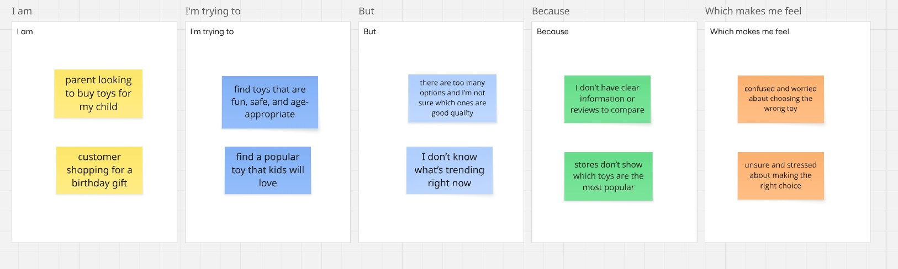

Problem  Statement  (PS) | I am (Customer) | I’m trying to | But | Because | Which makes me  feel
PS-1 | parent looking to buy toys for my child | find toys that are  fun, safe, and ageappropriate | I’m not sure which ones are good quality | I don’t have clear information or reviews to compare | confused and worried
PS-2 | customer shopping for a birthday gift | find a popular toy that kids will love | I don’t know  what’s trending right now | stores don’t show which toys  are the most popular | unsure and stressed

